To show the MAC address table: command 🡪 show mac address-table

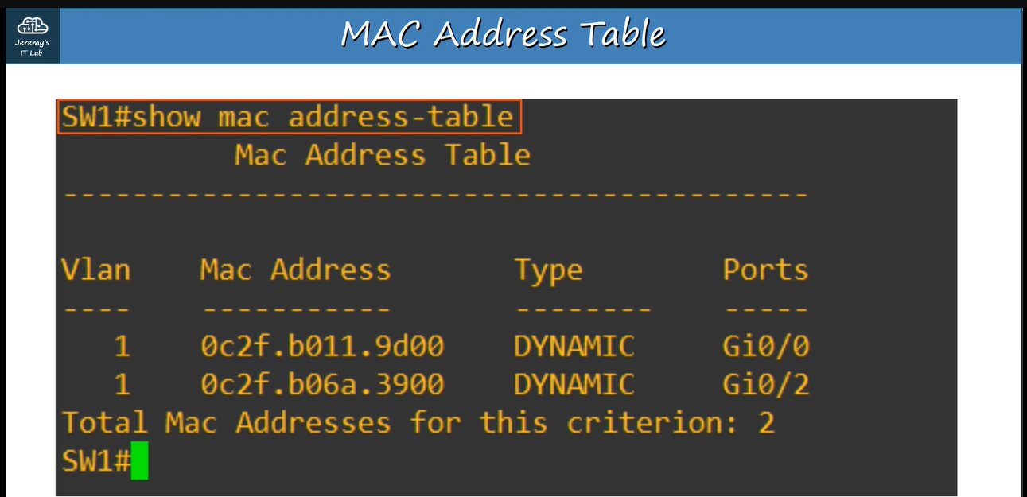

After 5 minutes of inactivity, all MAC addresses are removed and it is called “aging”

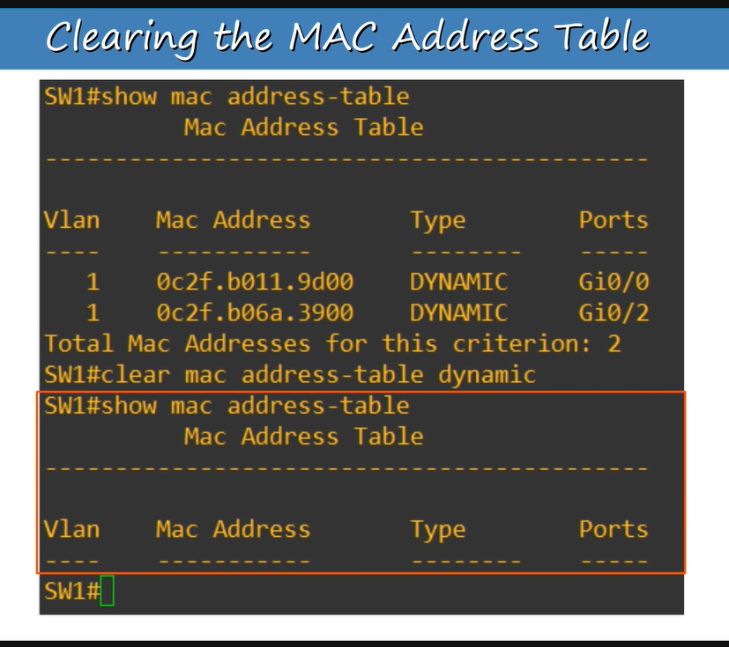

To clear all MAC addresses: command 🡪 clear mac-address table dynamic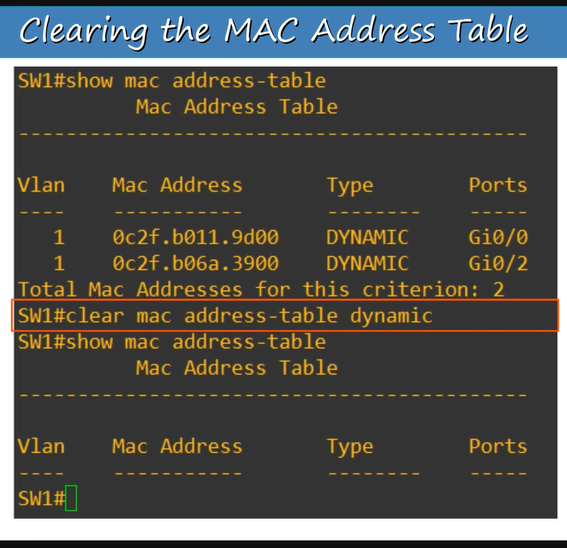

To clear a particular MAC address. There are two commands

1)clear mac address-table dynamic address ‘MAC address of the device’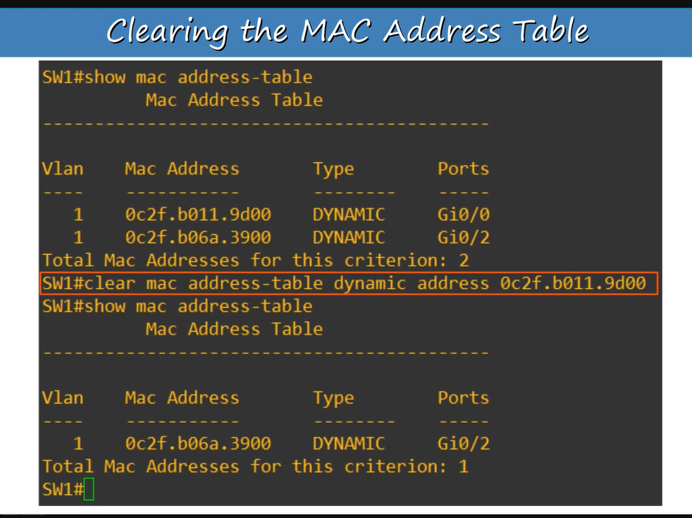

2)clear mac address-table dynamic interface ‘interface-id’